Wallenius' noncentral hypergeometric distribution

Intro

Wallenius' noncentral hypergeometric distribution (named after Kenneth Ted Wallenius) is a generalization of the [hypergeometric distribution](https://en.wikipedia.org/wiki/Hypergeometric_distribution) where items are sampled with [bias](https://en.wikipedia.org/wiki/Biased_sample).

Parameter

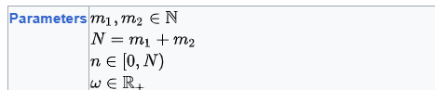

Support

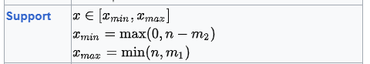

PDF

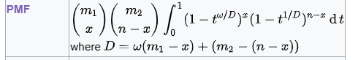

CDF

Expected Value

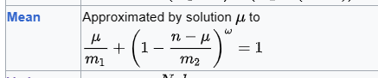

Variance

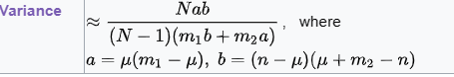

Property

Symmetric

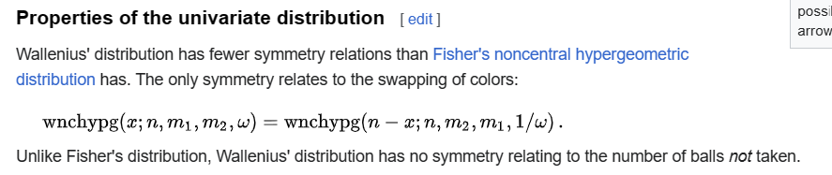

Ref

[Wallenius' noncentral hypergeometric distribution - Wikipedia](https://en.wikipedia.org/wiki/Wallenius%27_noncentral_hypergeometric_distribution)